**Report Assignment 1:**

**Code of Test_employee.py:**

import unittest

from unittest.mock import patch

from employee import Employee

class TestEmployee(unittest.TestCase):

@classmethod

def setUpClass(cls):

print('setupClass')

@classmethod

def tearDownClass(cls):

print('teardownClass')

def setUp(self):

print('setUp')

self.emp_1 = Employee('Arun', 'Zaheer', 50000)

self.emp_2 = Employee('Akash', 'Nazir', 60000)

def tearDown(self):

print('tearDown\n')

def test_email(self):

print('test_email')

self.assertEqual(self.emp_1.email, 'Arun.Zaheer@email.com')

self.assertEqual(self.emp_2.email, 'Akash.Nazir@email.com')

self.emp_1.first = 'Rahim'

self.emp_2.first = 'Hassan'

self.assertEqual(self.emp_1.email, 'Rahim.Zaheer@email.com')

self.assertEqual(self.emp_2.email, 'Hassan.Nazir@email.com')

def test_fullname(self):

print('test_fullname')

self.assertEqual(self.emp_1.fullname, 'Arun Zaheer')

self.assertEqual(self.emp_2.fullname, 'Akash Nazir')

self.emp_1.first = 'Rahim'

self.emp_2.first = 'Hassan'

self.assertEqual(self.emp_1.fullname, 'Rahim Zaheer')

self.assertEqual(self.emp_2.fullname, 'Hassan Nazir')

def test_apply_raise(self):

print('test_apply_raise')

self.emp_1.apply_raise()

self.emp_2.apply_raise()

self.assertEqual(self.emp_1.pay, 52500)

self.assertEqual(self.emp_2.pay, 63000)

def test_monthly_schedule(self):

with patch('employee.requests.get') as mocked_get:

mocked_get.return_value.ok = True

mocked_get.return_value.text = 'Success'

schedule = self.emp_1.monthly_schedule('May')

mocked_get.assert_called_with('http://company.com/Zaheer/May')

self.assertEqual(schedule, 'Success')

mocked_get.return_value.ok = False

schedule = self.emp_2.monthly_schedule('June')

mocked_get.assert_called_with('http://company.com/Nazir/June')

self.assertEqual(schedule, 'Bad Response!')

if __name__ == '__main__':

unittest.main()

**Code of Employee.py:**

import requests

class Employee:

"""A sample Employee class"""

raise_amt = 1.05

def __init__(self, first, last, pay):

self.first = first

self.last = last

self.pay = pay

@property

def email(self):

return '{}.{}@email.com'.format(self.first, self.last)

@property

def fullname(self):

return '{} {}'.format(self.first, self.last)

def apply_raise(self):

self.pay = int(self.pay * self.raise_amt)

def monthly_schedule(self, month):

response = requests.get(f'http://company.com/{self.last}/{month}')

if response.ok:

return response.text

else:

return 'Bad Response!'

**Resullt:**

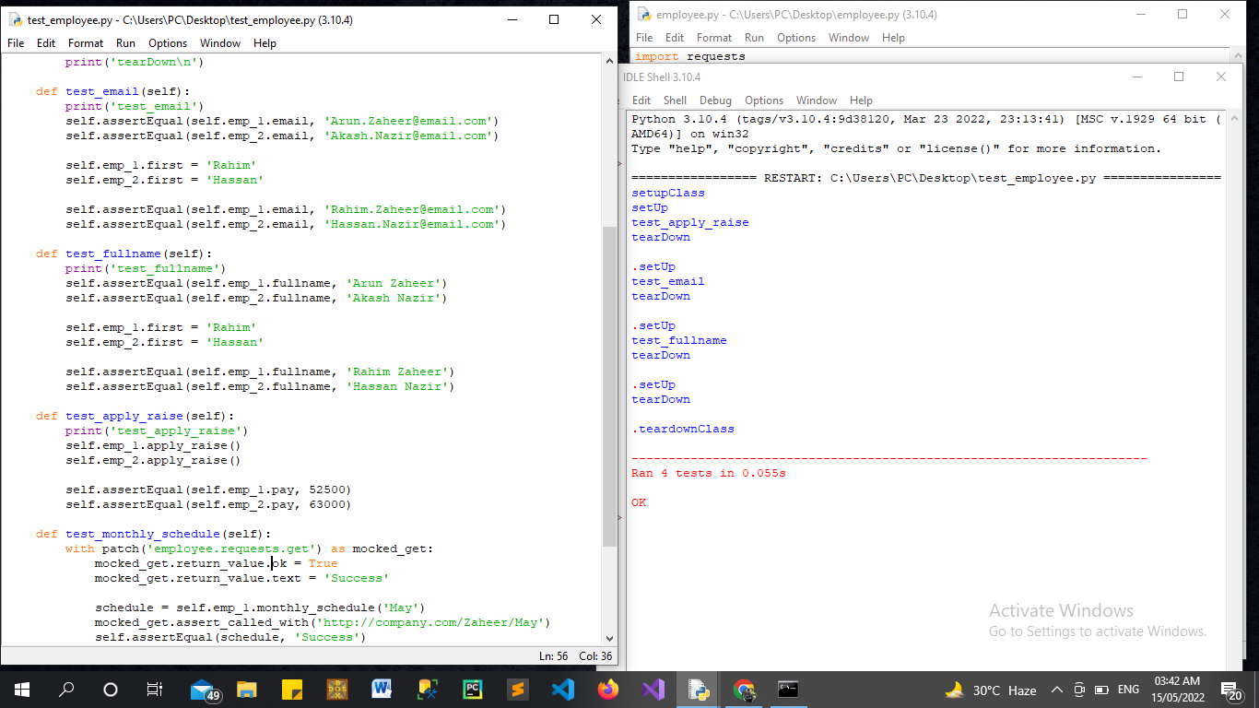

**Report Details:** I have created 4 tests and run all of them they passed the test.

These Test included  **TEST FULLNAME, TEST_EMAIL_TEST_APPRAISE,TEST_SCHEDULE**

I had given my name and my friends name as parameters on which test should be performed. And those names are ARUN ZAHEER, RAHIM, HASSAN, AKASH NAZIR